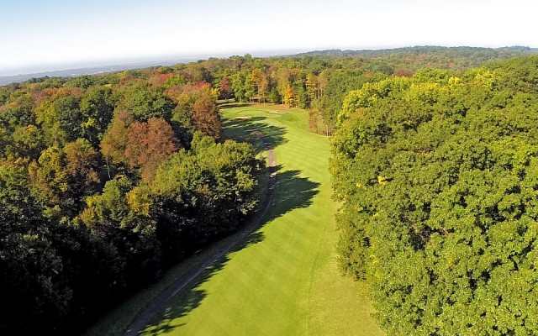

Treasure Lake
Prayer walk
(A self-guided tour)

Supporting our community
during a time of great need

Join in praying for our community, our nation and our world
as we are all buffeted by the Covin-19 pandemic.

- Treasure Lake Residents are welcome to walk the cart path through the “Gold” golf course while the course is not open for play.
- Please remember to follow all safety instructions and guidelines that have been issued by the CDC, State and National Government. (Limited number of people, social distancing, Etc.)

Starting point: Park at Duffers. Cross Caribbean Road which takes you to hole 1.
(refer to map below)

While walking …
Hole one -
Pray for the health of everyone in the Tri-county, the residents of Treasure Lake and the employees of the Treasure Lake POA. Pray that God will protect us and shield us from this virus. Pray specifically for people in your family and your neighbors.

Hole two -
Pray for the health professionals across the globe, who form our first line of defense against this virus. Pray for their safety and strength while they care for the sick. Pray specifically for the great staff at Penn Highlands. (Mention your own physician, and medical personnel you know.)

Hole three -
Pray for our health and research community as they strive to create and provide medicines that will tame this virus and strengthen those who are ill. Pray that God will give them insight and perseverance. Pray for those laboring at the CDC, who strategize next steps for this nation.

Hole four -
Pray for the world’s economy that is suffering from a near shutdown. Pray for those who find themselves with greatly scaled back income, or no income at all. Pray for wise policies to be pursued that will navigate us through these difficulties. Please mention by name people you know whose work is shut down during this crisis.

*This is a great place to take a selfie. Please post your picture on the Treasure Lake Church Facebook page. You will encourage others as you let them know you are part of this prayer movement.

Hole five -
Pray for those who are particularly vulnerable to this virus. Ask God to protect the elderly, those with immune challenges and those who are in chemo-therapy. Pray that God will sustain them as they are isolated from those whom they love.

Hole six -
Pray for our authorities who are guiding us through these difficult days. Pray that Governor Wolf will make wise decisions. Pray for our national leadership as they continue to lead us through this crisis.

Hole nine and back to Duffers –
Pray that this community will unite during this difficulty. Pray that we will be good neighbors. Pray that we will seek God. Pray for the person you are walking with.

